 |  | Rice Disease Diagnostic System  A Rule-Based Rice Disease Diagnosis System Using Symptoms  Socheat Sek [1], San Reaksmey [2], Try Reaksmey [3], Pen Panhna[4], That Kongkea [5]  [1] Department of Computer Studies, College of Science, Norton University, Kingdom of Cambodia | 
- Introduction  Rice is an important crop in Cambodia, but is severely affected by diseases that reduce yield and quality if not detected early. Many farmers lack access to experts, making observational diagnosis difficult and sometimes inaccurate. To address this problem, the project developed a rules-based rice disease diagnosis system that uses visible symptoms to provide immediate results. The system also provides weather information for each province, Khmer-English support, and provides preventive and treatment advice to help farmers take the right action. | 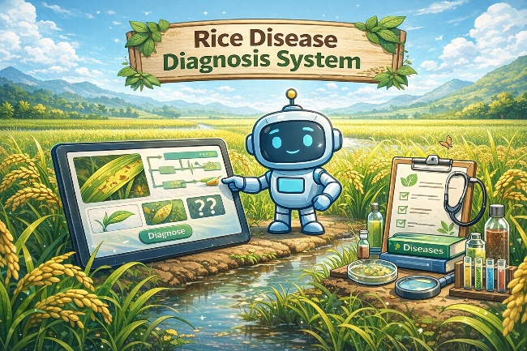
3. Project Goal
2. Problem Statement

- Farmers often lack sufficient agricultural knowledge to identify rice diseases correctly.
- There is limited access to agricultural experts, especially in rural areas.
- Different rice diseases can show similar symptoms, making diagnosis difficult.
- Delayed or incorrect diagnosis can lead to serious crop loss and reduced yield.
- Traditional disease identification methods are time-consuming and not always accurate.
- Existing solutions or expert consultations require high cost (need more budget).
- There is a need for a simple, fast, and accessible solution for rice disease diagnosis.
The goal of this project is to create a simple, rules-based system that helps farmers diagnose rice diseases using visible symptoms. It aims to provide quick and accurate identification without the need for expert assistance. The system also provides preventive methods and treatment recommendations to reduce crop losses. In addition, it supports both Khmer and English languages ​​to ensure easy access for all users.

4. Key Features
Confidence Level
Diagnosis Result

Rule-Based Expert System & Inference Engine
Rule Based Access Control (RBAC)
- Defines roles: Admin, Expert, User
- Controls access to system features
- Protects data and system security
- Manages user permissions
- Shows disease name
- Provides explanation
- Suggests treatment methods
- Recommends prevention strategies
- Displays accuracy level
- Based on matched symptoms
- Helps decision-making
- Increases user trust
- Uses IF–THEN rules
- Matches symptoms with diseases
- Processes logic automatically
- Generates diagnosis results














We sincerely thank Prof. Socheat Sek (Prof, Norton University) for valuable support and guidance.
The Rice Disease Diagnosis System helps farmers quickly and accurately identify rice diseases using a rule-based approach. It improves decision-making by integrating weather information, market price, and bilingual support (Khmer and English). Overall, the system reduces crop loss and supports smarter and more efficient agriculture.
- Improve diagnosis speed and accuracy
- Reduce crop loss and increase productivity
- Support better decisions using weather and market data
- Enhance accessibility with Khmer and English support
- Enable data tracking for smart agriculture development
7. Expected Impact
6. Technical Approach
5. Target Users
9. Acknowledgement
8. Conclusion
- Symptom Input
Users select observed symptoms through the interface.
- Rule Matching (IF–THEN Rules)
The system matches symptoms with predefined rules.
- Inference Engine Processing
Applies logic to determine the most likely disease.
- Knowledge Base
Stores diseases, symptoms, and related rules.
- Diagnosis Generation
Produces the final diagnosis result.
- Result Output
Displays explanation, treatment, prevention, and confidence level.
St. Keo Chenda, Sankat Chroy Changvaar, Khan Chroy Chongvar, Phnom Penh, Cambodia
www.norton-u.com (+855) 93 888 569 / (+855) 93 888 359 info@norton-u.com

Experts (Agronomists)
Support research and smart agriculture.
Researchers & Organizations
Improve and update system knowledge.
Farmers
Agriculture Students
Learn rice disease diagnosis.
Identify diseases and improve crop yield.

